Title of article (max 100 characters)

ORIGINAL LANGUAGE
EXAMPLE
Viejos puertos, nuevas ideas: el diseño en doble ciclo

ENGLISH (Translation of Author)

EXAMPLE
Old ports, new ideas: two-cycle design

Abstract of article (max 1.000 characters)

In ENGLISH
(only for the following sections of the magazine: REPORT, FOCUS)

EXAMPLE
The transformation of ports and waterfronts over the last 50 years has produced the most interesting and innovative spaces in big cities. Shanghai’s Bund, the old mooring place and loading wharf, has become the most emblematic civic space in the metropolis, going from a peripheral relation with the river Huanpu to a waterside promenade that communicates spectacularly with the commercial hub of Pudong.
Manhattan’s waterfront on the Hudson is its most buoyant real-estate sector, and the High Line recycles an old railway line beside the port as a raised greenway of exclusive design.
Paris is rehabilitating the former Renault site on Île Seguin in the Seine with the aim of creating new downtowns away from the traditional city centre.
These are some examples of how new ideas have developed in obsolete spaces that used to have other functions and were never conceived as multifunctional spaces with important civic and symbolic values. It is as though recycling obsolete spaces were a necessary condition for innovation.

Keywords+Cities

In ENGLISH

(Max 10 keywords, including the name of the Countries and the Cities mentioned in the article)
NB. All keywords separated by a comma, with the first letter capitalized.

EXAMPLE
Ports and waterfront, Recycling of spaces, Shanghai, Manhattan, Paris, Buenos Aires

Text of Article
(approximately 10.000 characters for REPORT and FOCUS)
(approximately 4.000 characters for all other sections of the magazine)

ORIGINAL LANGUAGE
IMPORTANT:
1. Do not insert a subtitle at the beginning of the text
2. Indicate in the text the exact position of the photo / image / table / video, with this sentence (Photo_01) or (Image_01) or (Table_01) or (Video_01).
The number corresponds to the photo / image / table / video file and caption.

EXAMPLE

La comprensión territorial es una tarea compleja y apasionante, en especial en regiones con una notable carga histórica. En cualquier escenario litoral, y específicamente en lo que al Mediterráneo se refiere, no se pueden separar las realidades marítimas de tierra firme.
………

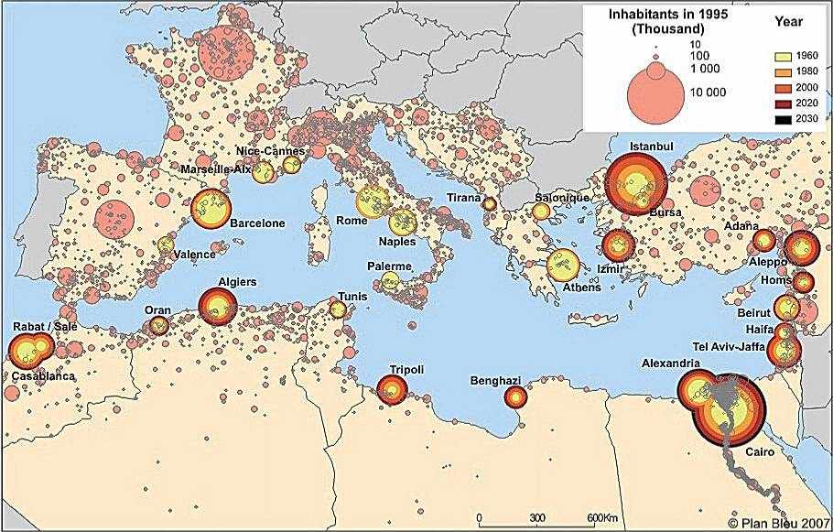
Image_01
Distribución de la población en 1995. (Houpin S., 2010, “Urban mobility and sustainable development in the Mediterranean. Regional diagnostic outlook”, Plan Bleu, Sophia Antipolis) OR (© Mario Rossi, 2013 ) OR (http://en.wikipedia.org/wiki/Famagusta).

Paragraph Title (Bold)

El incremento de la escala y densidad del tráfico marítimo [1] y más concretamente las respectivas especializaciones, junto al descenso de la actividad piscatoria han desencadenado un importante desequilibrio territorial. Turismo, tráfico de contenedores y una menor pesca constituyen el trinomio sobre el que se asienta esta situación.
………

Sub-paragraph (Italic)

La primavera árabe necesita de fondos que ayuden a reforzar determinadas estructuras. La ciudad y el puerto, como símbolos de este secretariado de la UfM, están llamados a relacionarse en mayor modo y surgen oportunidades para centralizar los esfuerzos en ese sentido.

- Una actividad piscatoria casi desaparecida y un tránsito de mercancías deslocalizado a puertos de mayor escala por razones comerciales o políticas abren una ventana de posibilidades para repensar las nuevas funciones de la ciudad-puerto.
..........
- En el caso de Saïda la presencia de familias palestinas parece reequilibrar parcialmente esta situación, en especial en la zona próxima al castillo de tierra.
..........

Notes

EXAMPLE

[1] http://www.planbleu.org/publications/4p_urbain_uk.pdf
[2] From “Plan Bueu” data reports, about the Mediterranean Transport
[3] All the processes abut changes and renovation of the Mediterranean ports can be consulted on http://www.euromedaviation.org/90.0.html?&L=0
[4] Wright, JR, Vesonder, GT & Dasu, T (2007), “Management of data-streams for large scale data mining”, in L. Al-Hakim (ed.), Challenges of managing information quality in service organizations, Idea Group Publishing, Hershey, Pennsylvania
[5] Chang, P (ed.) (2007), Tourism management in the 21st century, Nova Science Publishers, New York

References

EXAMPLE

A dictionary of business and management (2009), 5th edn, Oxford University Press, Oxford.

Australian Bureau of Statistics (2006), A picture of the nation: the statistician's report on the 2006 census, cat. no. 2070.0, Australian Bureau of Statistics, Belconnen, ACT.

Badot, O. & Cova, B. (2008), “The myopia of new marketing panaceas: the case for rebuilding our discipline”, in Journal of Marketing Management, vol. 24, no. 1/2, pp. 205-219.

Burton, M., Nesiba, R. & Brown, B. (2010), An introduction to financial markets and institutions, 2nd edn, M.E. Sharpe, Armonk, NY.

Article Translation
(approximately 10.000 characters for REPORT and FOCUS)
(approximately 4.000 characters for all other sections of the magazine)

In ENGLISH and OPTIONAL

IMPORTANT:
1. Do not insert a subtitle at the beginning of the text
2. Indicate in the text the exact position of the photo / image / table / video, with this sentence (Photo_01) or (Image_01) or (Table_01) or (Video_01).
The number corresponds to the photo / image / table / video file and caption.

